**Managing Change**

**Delegate Workbook**



**Managing Change**

**Module Aims**

*On completion, you will:*

* Understand the difference between innovation and change
* Be aware of relevant tools to help you to manage change effectively
* Be able to communicate innovation and change effectively
* Understand the effects of innovation and change on people and teams

Indicative content:

* Types of change
* Barriers to change
* The change curve
* Managing creativity
* The changing world of work
* Planning tools
* Tools to monitor and review the implementation of change and innovation

**Managing Change**

1. **Understanding Change**
   1. **What is Change?**

How I feel about change?

Here are a few points to consider. Change;

* is different for everyone
* has a process
* has an emotional transition
* may be influenced by individual preferences and their previous experiences of change
* may be influenced by the size/magnitude

Think of a time when you have experienced change at work and reflect on the process.

What happened?

How did you feel at the start?

How long was the process?

Did you feel differently at the end?  If so, what contributed to this?

* 1. **Types of Change**

**“The first step toward change is awareness. The second step is acceptance.”**

*Nathaniel Branden*

Ackerman (1997) distinguished between three types of change. Note the differences:

Developmental

Transitional

Transformational

* 1. **How change occurs**

Change can impact an organisation in a number of ways:

Mintzberg identified two ways in which change occurs, as shown in the diagram below:

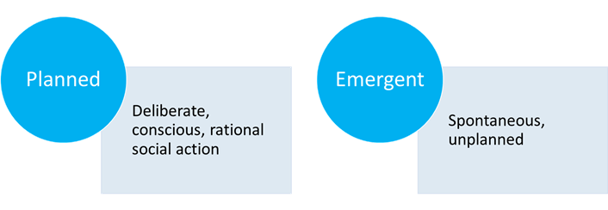

Take some time to work through the online activity and identify what gets in the way of successful change. Then think about how you could overcome the areas you have identified. You may want to save the document or alternatively paste the table into your workbook.

1. **Understanding Innovation**
   1. **Creativity versus Innovation**

What is the difference between creativity and innovation? According to Dr William Coyne, of 3M he defined the difference as follows:

* Creativity is
* Innovation is

"Genius is 1% inspiration and 99% perspiration"

***Thomas Edison***

Capture as many benefits as you can in the following table, considering the following:

* What are the potential benefits of change and innovation?
* What are the consequences of not changing or innovating?

|  |
| --- |
| **The benefits of change and innovation** |
|  |
| **The consequences** |
|  |

Now you have your ideas, think of examples of companies, technologies etc where change and innovation has been successful or unsuccessful. You may wish to research this further.

|  |
| --- |
| **Examples - successful** |
|  |
| **Examples - unsuccessful** |
|  |

**Your notes:**

* 1. **Managing Creativity**

Everyone is capable of being creative and there are many ways of encouraging this. List some of your own here:

At work, one area where team creativity can add value is problem solving. This could relate to any of the following issues which need creative thought:

**Your notes:**

* 1. **The Future World of Work**

**In your own time, fast forward 20 years and consider, what will be different in the world of work?**

How will you manage your teams?

What skills will be needed for the future?

1. **Planning Innovation and Change**
   1. **About PESTLE**

A PESTLE analysis is often used as a broad fact-finding activity. It helps an organisation establish the external factors that could impact decisions made inside the organisation therefore can be particularly useful when preparing for change

**Advantages**

**Disadvantages**

**Tips for using the tool**

* Collaborate – multiple perspectives will deliver a better outcome.
* Use PESTLE alongside other techniques, such as SWOT analysis, Porter’s Five Forces, competitor analysis, or scenario planning.
* Consider any expertise and resources already available within the organisation.
* Incorporate the analysis into an ongoing process for monitoring changes in the business environment.
* Don’t jump to conclusions about the future based on the past or present
  1. **SWOT Analysis**

**What is a SWOT Analysis?**

SWOT stands for

Its is used for

**Points to remember when using a SWOT analysis**

**Your notes:**

* 1. **Tools for monitoring and reviewing**

We have looked at some tools which may be useful when planning change. However, you also need to consider what other mechanisms you may need.

Whilst many of the change models we will consider serve as a useful checklist, they do not enforce use of any actionable steps or timescales. Therefore, we need to ensure any change programme makes use of relevant tools to keep the programme on track and to be able to monitor its effectiveness.

**What tools can we use to plan, monitor and review progress of change and innovation projects?**

1. **Managing Innovation and Change**
   1. **Drivers for and Barriers to Change**

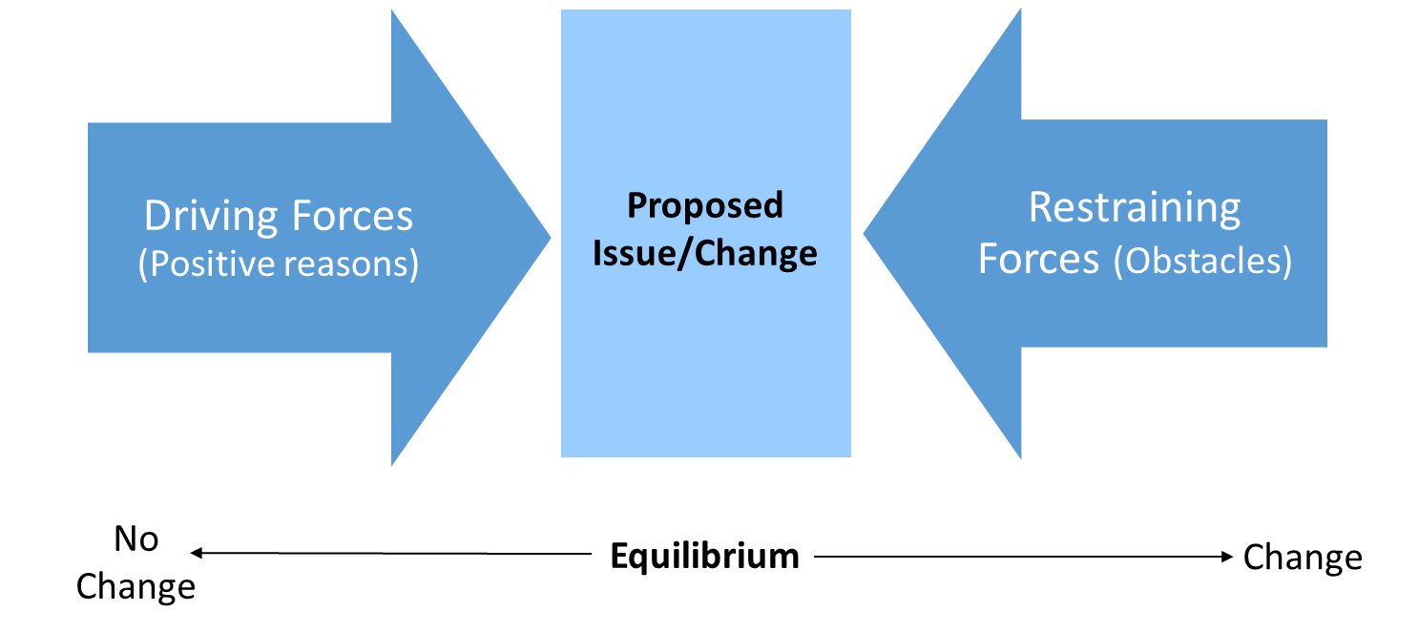

*Lewin’s Force Field Analysis*

**Driving forces:**

**Restraining forces:**

**Your notes:**

* 1. **The Change Curve**

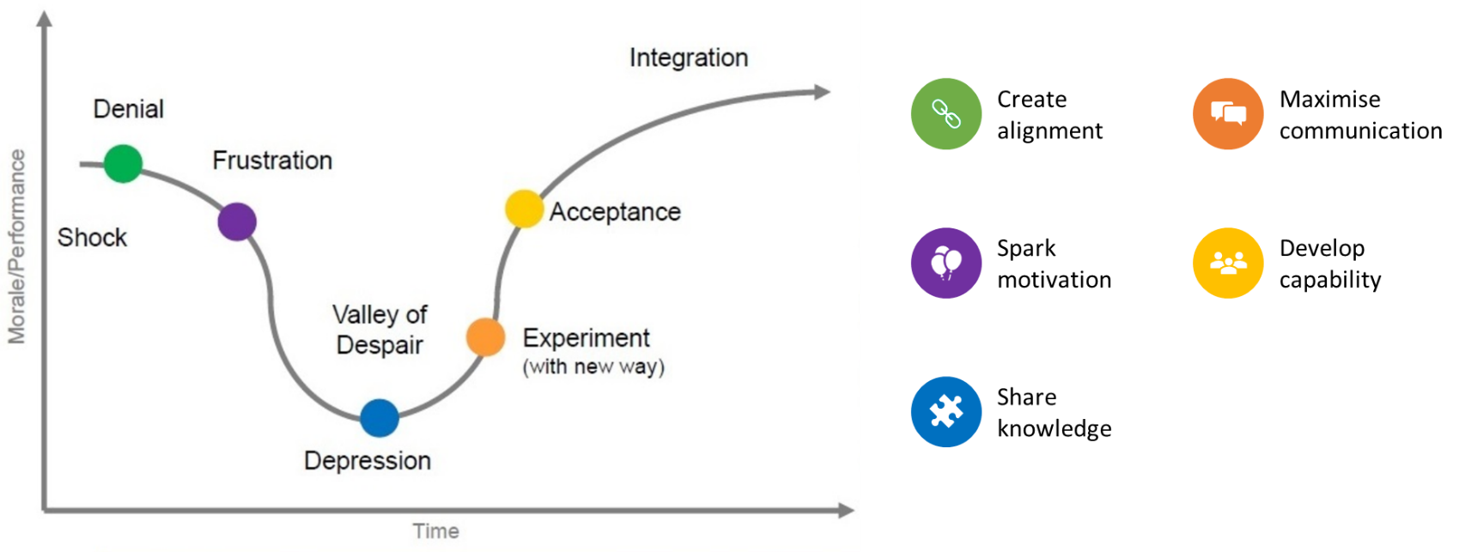

Originally developed by Kubler-Ross, the Change Curve is a model that explains the grieving process. However, it has been adopted as a useful tool to apply when taking staff through a period of major change, such as restructuring, merger or acquisition.

The Change Curve describes the stages anyone must go through when faced with a change in their lives. From grieving a loved one to changing an IT system, people have to experience the same stages of personal development in order to move on. These stages describe seven states of emotion:

**Useful tips:**

**Useful tips:**

* People will progress through these phases at different speeds, so for example some people can accept change fairly readily, whilst others may get “stuck” at a stage, such as denial, or depression.
* Not everyone experiences every phase. People may skip, or even relapse.
* Appreciating where people are will help you to manage them appropriately.

**Your notes:**

* 1. **A Process for Change**

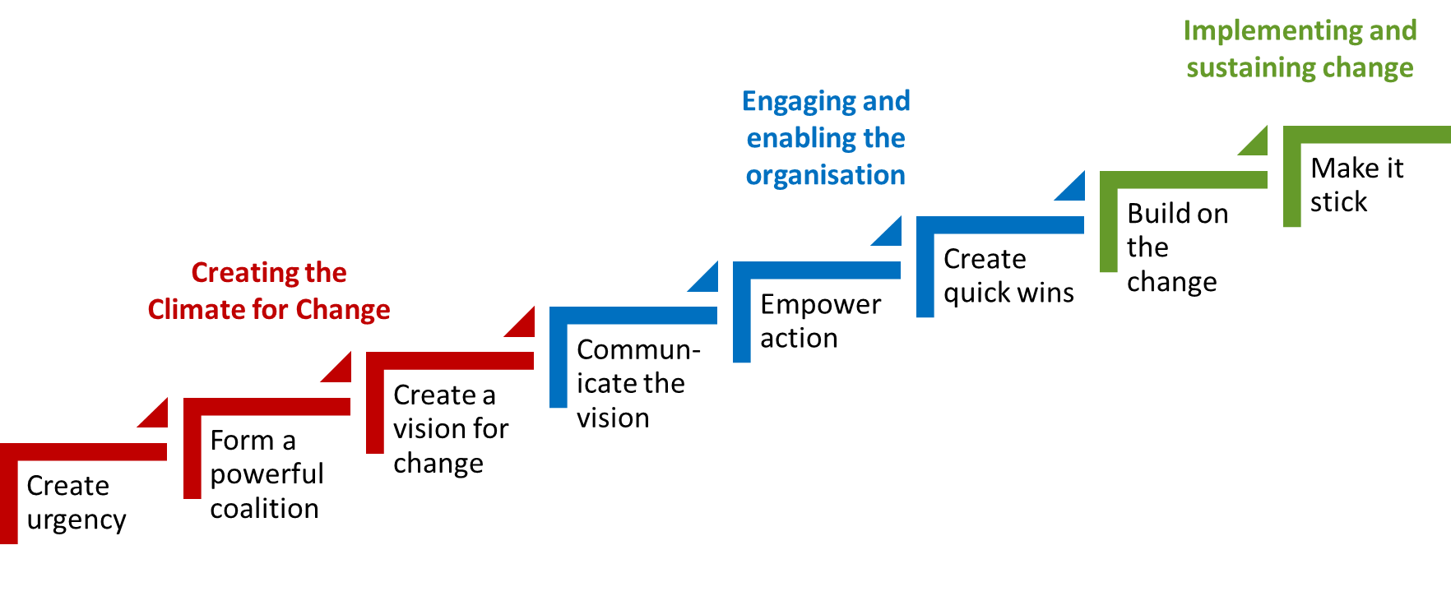

**John P Kotter's 'eight steps to successful change'**

Create Urgency

Form a Powerful Coalition

Create a Vision for Change

Communicate the Vision

Empower Action

Create Quick Wins

Build on the Change

Make it Stick

1. **Basic Change Management Principles**

To summarise some of the key principles when managing change:

1. At all times involve and agree support from people within system (system = environment, processes, culture, relationships, behaviours, etc., whether personal or organisational).
2. Understand where you/the organisation is at the moment.
3. Understand where you want to be, when, why, and what the measures will be for having got there.
4. Plan development towards above (No.3) in appropriate achievable measurable stages.
5. Communicate, involve, enable and facilitate involvement from people, as early and openly and as fully as is possible.

**Your notes:**

***Further reading:***

*William Bridges, Managing Transitions: Making the Most of Change (4th edition, 2017)*